**Smart Car Parking System in Python Source Code**

The Car Parking System in Python is a desktop application coded in a Python programming language. The project contains all the need function to make the parking of cars in the parking area. This project was create to help you to organize the parking of cars in the lot. It provide a simple way for assigning a parking slot to each vehicle in the area. This Car Parking System is a simple project that could benefit student taking computer related courses. It can benefit you if you are looking for a system related to this project. This Car Parking System in Python can provide some learning material who are interested inPython programming.

**Project Title: Parking Management System Project in Python with Source Code**

Abstract : Parking Management System Project in Python refers to the innovative technologies providing solutions in the parking industry.

Project Type: Web Application

Technology : PyCharm IDE Platform

Language: Python

Database : MySQL

Developer: IT Source Code

**About smart Car Parking System:**

The Car Parking System built using only Python programming language. This system is a user-friendly kind of system that can easily fit to your needs. The system provide you a simple navigation for assigning a parking space to each vehicle. It allow the user to create your parking space by assigning the column and row of the area. You can also remove a parked vehicle by entering their numbers.

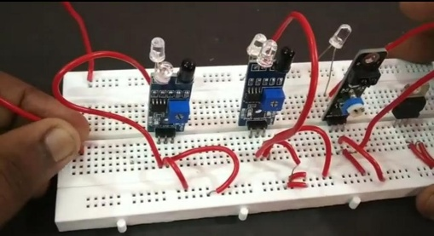

**Codings:**

Import RPi.GPIO as GPIO

Import time

# Set up GPIO

GPIO.setmode(GPIO.BCM)

# Define pin numbers

IR_SENSOR_PIN = 17 # Example GPIO pin, adjust as needed

LED1_PIN = 18

LED2_PIN = 19

LED3_PIN = 20

# Initialize GPIO pins

GPIO.setup(IR_SENSOR_PIN, GPIO.IN)

GPIO.setup(LED1_PIN, GPIO.OUT)

GPIO.setup(LED2_PIN, GPIO.OUT)

GPIO.setup(LED3_PIN, GPIO.OUT)

Def check_parking_status():

If GPIO.input(IR_SENSOR_PIN) == GPIO.LOW:

Return True # Car detected

Else:

Return False # No car detected

Def indicate_parking_status(status):

If status:

GPIO.output(LED1_PIN, GPIO.HIGH) # LED1 ON

GPIO.output(LED2_PIN, GPIO.LOW) # LED2 OFF

GPIO.output(LED3_PIN, GPIO.LOW) # LED3 OFF

Else:

GPIO.output(LED1_PIN, GPIO.LOW) # LED1 OFF

GPIO.output(LED2_PIN, GPIO.HIGH) # LED2 ON

GPIO.output(LED3_PIN, GPIO.LOW) # LED3 OFF

Try:

While True:

Status = check_parking_status()

Indicate_parking_status(status)

Time.sleep(1)

Except KeyboardInterrupt:

GPIO.cleanup()

**Steps on how to run smart car parking system in python with source code**



